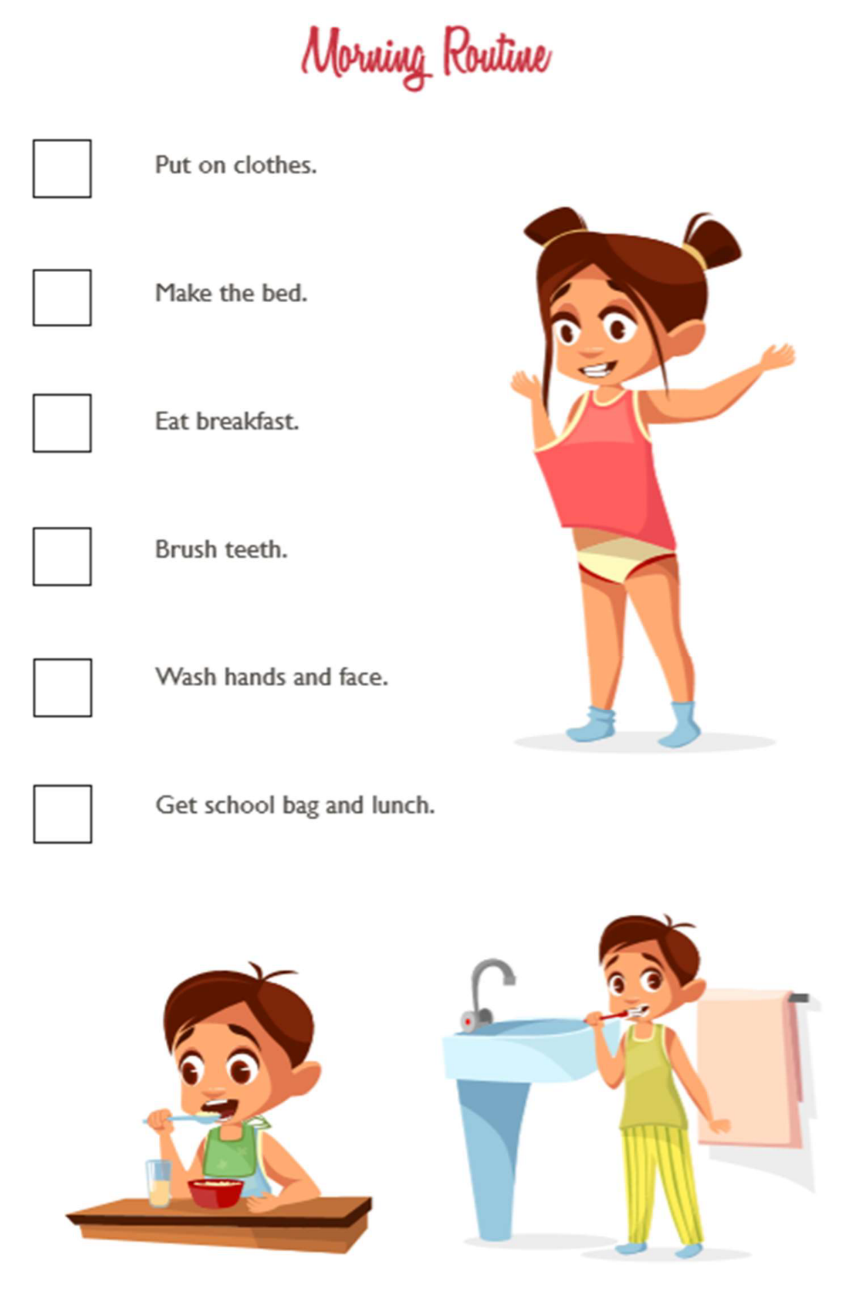

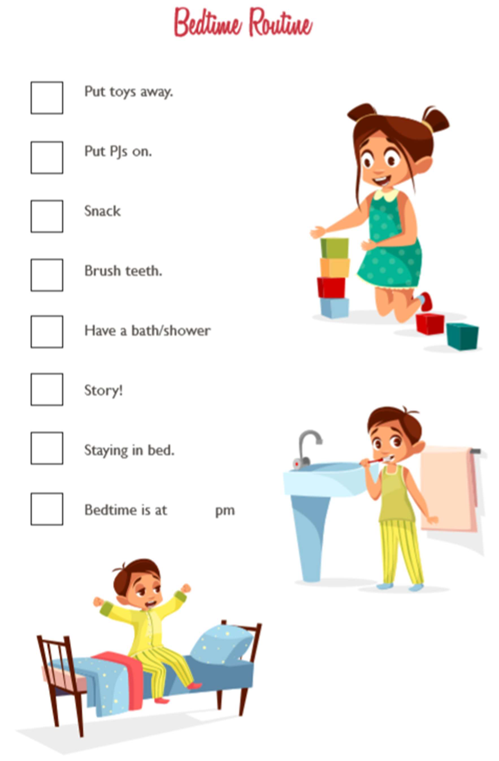

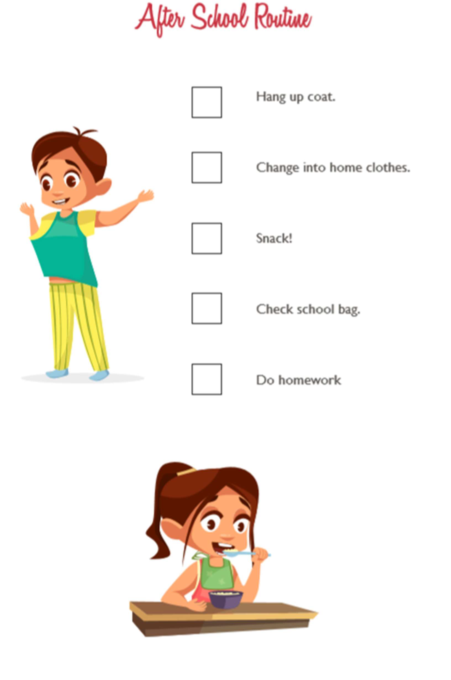

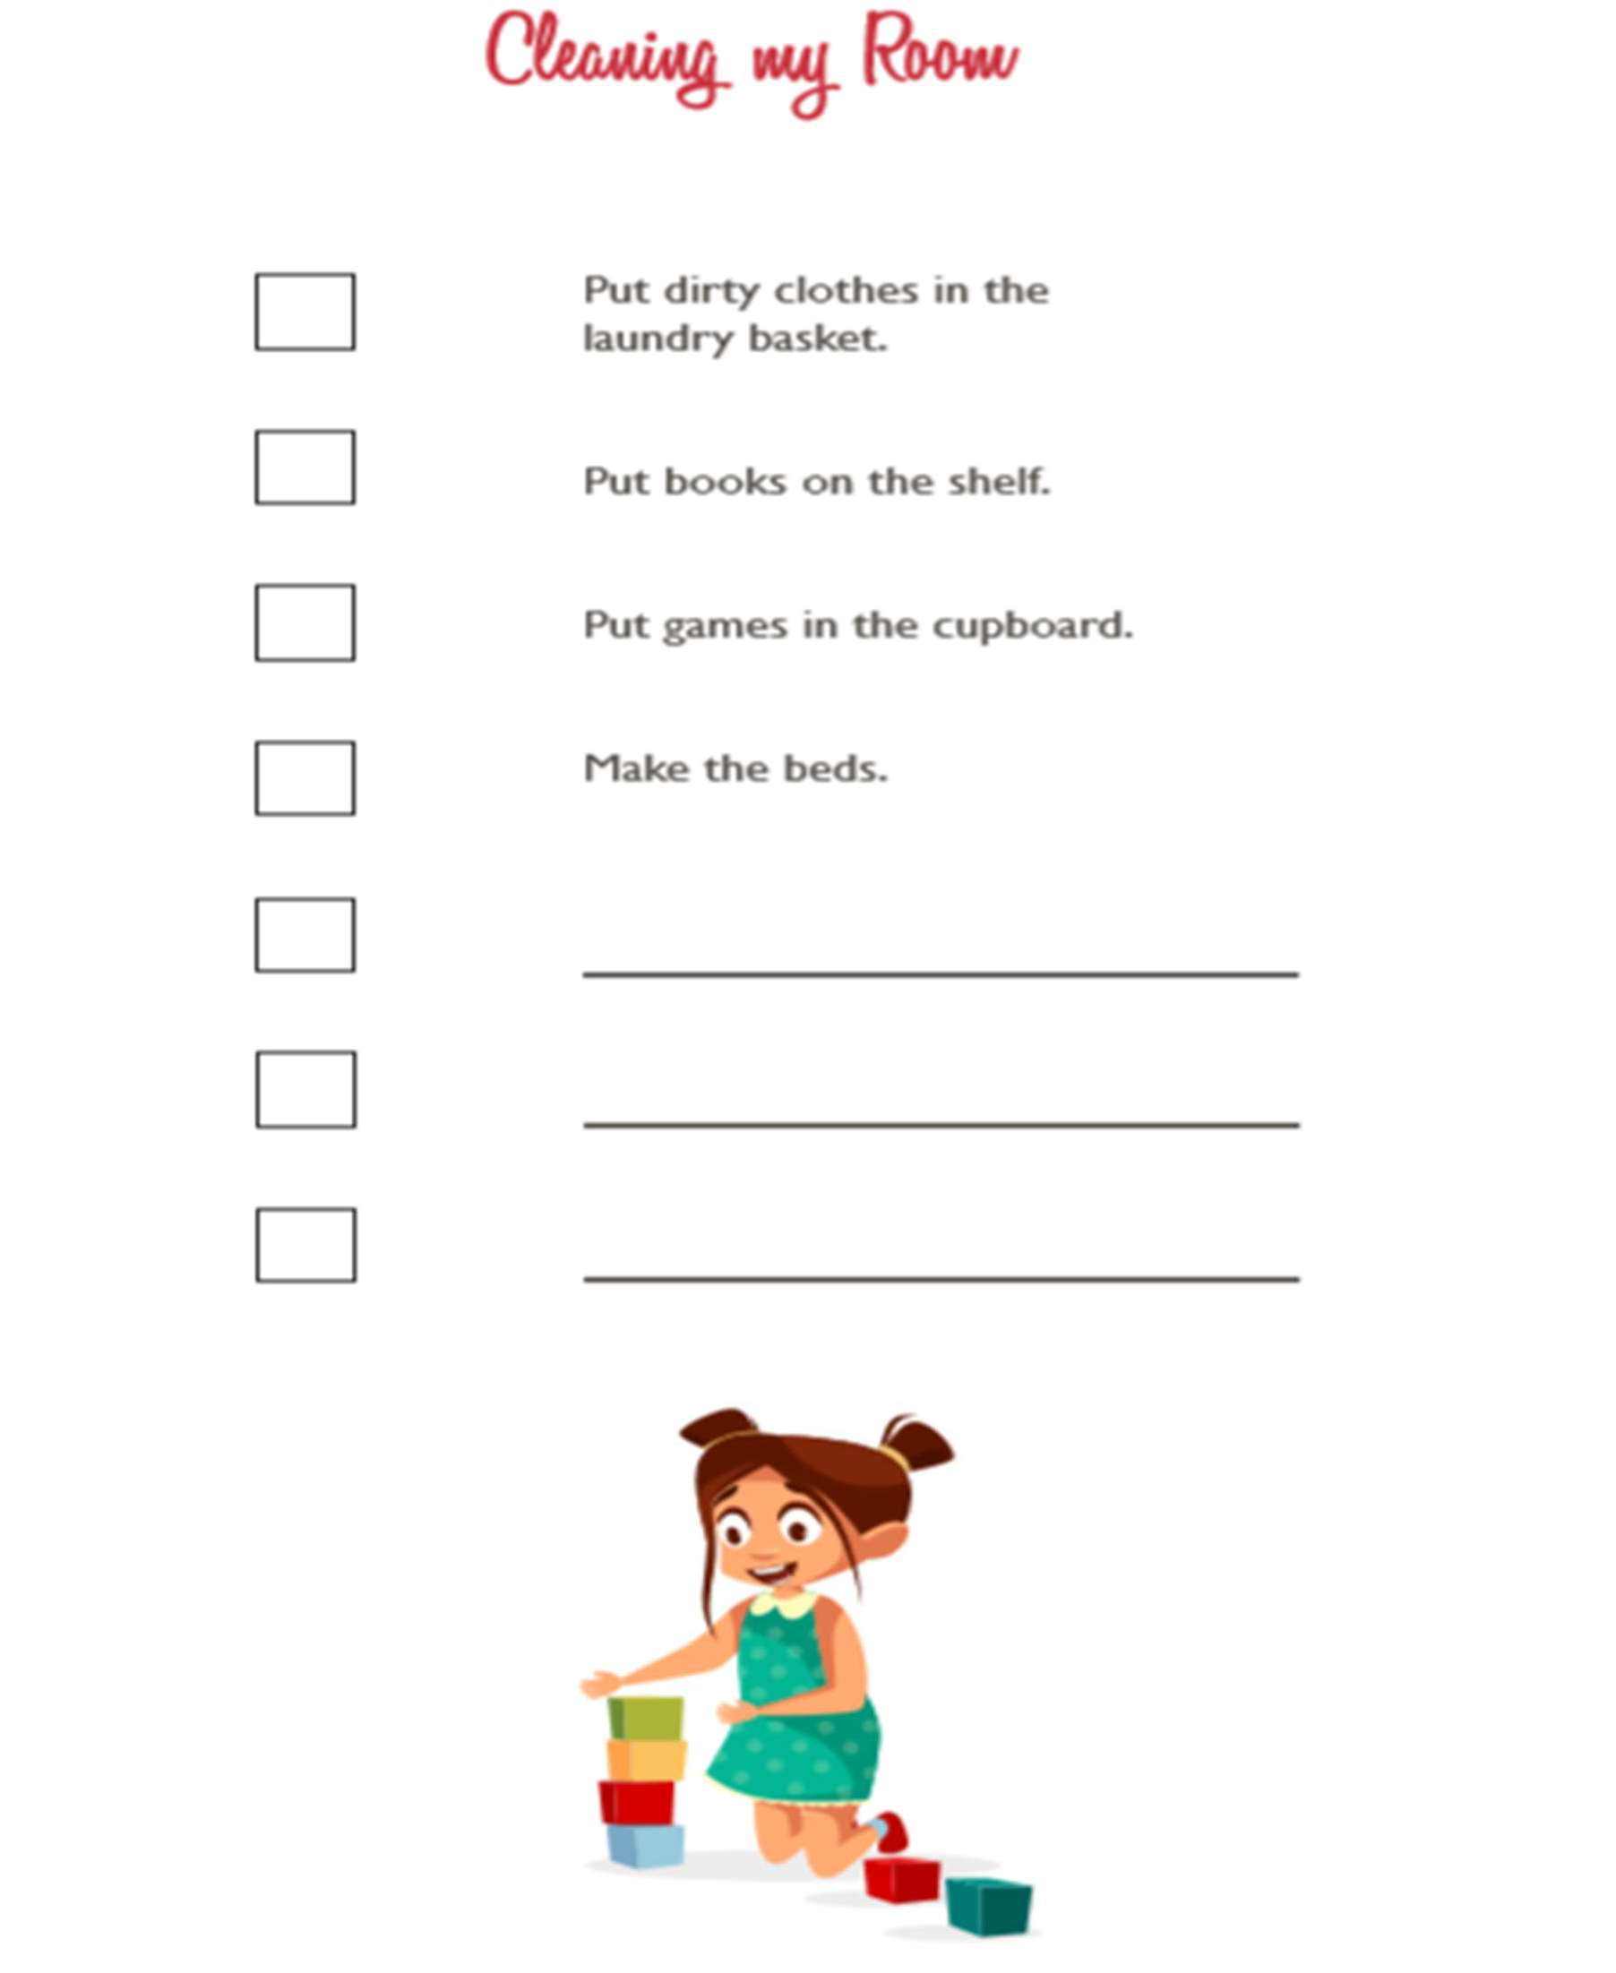

A simple daily schedule can help your child to plan what happens on each day and to make sure they have all that they need for school/an outing prepared the day before.

Monday | Tuesday | Wednesday | Thursday | Friday | Saturday | Sunday

A daily timetable can also help children understand what order things will happen.

You can either put the time of day – for example if you want them to make their bed by 8am
- or you can list things in the order that you would like them to be done, depending on your child. Using a visual timetable is also a good idea so they can see what to do next.

Monday Morning | Monday Evening
Wake up | Come out of school
Go to the toilet | Say hello
Wash hands | Get in car
Eat breakfast | Go home
Clean teeth | Have a snack
Get dressed | Watch TV
Brush hair | Do homework
Reward activity that motivates your child | Play ball
Put lunch in school bag | Have dinner
Coat on | Puzzle time
Shoes on | Bath time
Get in car | Wash hair
Go to school | Story time
Say goodbye | Bedtime

Taking pictures of your child doing the activity is helpful so that they can follow them, or pictures of the objects used, for example, toothbrush. Pictures of places you are going to go to e.g. school, shop, etc. can also give your child the security of knowing what comes next.

Another good way of helping children is to have a 2-sided chart and move the pictures to the other side once they have completed the task or to post them into a box (a shoebox with a cut out in the top is ideal).

You can also provide space to tick the items once they are done.

